BILKENT UNIVERSITY ENGLISH LANGUAGE PREPARATORY PROGRAM MATERIALS DESCRIPTION FORM

THEME: Unit 3 Cultural Studies | TITLE OF THE MATERIAL:U3 Vocabulary Revision

Please tick the course package the material will be used in.
- Q Skills Intro | ¨

SKILL: Vocabulary | OBJECTIVE(S) (Tick and fill in as appropriate) Students will be able to  - Practice Unit 3 Words

Prepared By:ELPP Instructors

HOW DO YOU CHOOSE YOUR FOOD?
What do you have for breakfast / lunch / dinner?




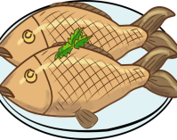
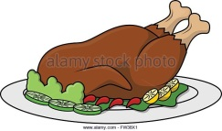
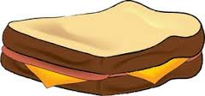


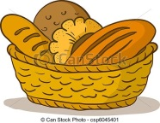







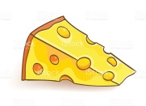


PART 1. Make sentences using the words in the pictures.
e.g. I have bread with butter and cheese for breakfast.
__________________________________________
__________________________________________
__________________________________________
________________________________for lunch.
__________________________________________
__________________________________________
__________________________________________
________________________________for dinner.
__________________________________________
__________________________________________
__________________________________________

Part 2. Match each adjective with its antonym.
- bad a. full
- careful b. interesting
- fast c. good
- funny d. boring
- happy e. ordinary
- boring f. wet
- cheap g. sad
- dirty h. clean
- different i. dark
- easy j. unimportant
- empty k. expensive
- important l. dangerous
- light m. slow
- safe n. careless
- dry o. difficult

Part 3. Fill in the blanks using the verbs in the box.
grow lose try choose mean close want cook

- I helped my sister to ________ a name for her baby.
- Lie down and ________ your eyes.
- Children ________ very quickly.
- My sister always ________ her car keys.
- The read light ________ stop.
- My father ________ meat in oil and spices.
- My parents ________ to buy a new car.
- You are very tired. ________ to have some rest.

